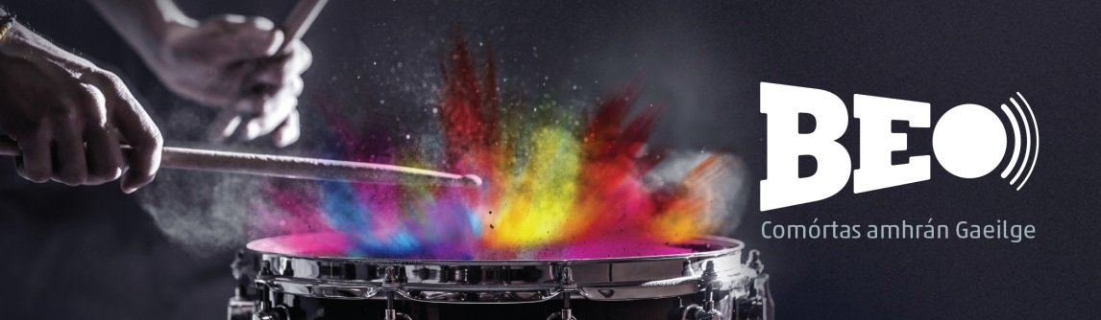
Foirm Iarratais
Múinteor/Meantóir: ________________________________________________________________
Scoil: _____________________________________________________________________________
Seoladh: __________________________________________________________________________
Rphost:___________________________________________________________________________
Uimhir theagmhála: _________________________________________________________________
Teideal an amhráin: _________________________________________________________________
Nasc don fhíseán: ___________________________________________________________________
Fad an amhrán:_____________________________________________________________________
Fad an fhíseáin: ____________________________________________________________________

Baill an Ghrúpa | Dáta breithe
1.

2.

3.

4.

5.

6.

7.

Uirlisí Ceoil a bheidh á seinnt
________________________________________________________________________________
________________________________________________________________________________
________________________________________________________________________________
________________________________________________________________________________

Spriocdháta:
Spriocdháta le hiarratas a chlárú agus físeán a sheoladh isteach go leictreonach chuig poconghaile@forasnagaeilge.ie: 16 Deireadh Fómhair 2017 ag 5.00 p.m.
Ceisteanna agus tuilleadh eolais:
Is féidir teagmháil a dhéanamh le Pádraig Ó Conghaile ag 353-1-6398400 nó ag poconghaile@forasnagaeilge.ie le tuilleadh eolais a fháil.

