Bláithín ar an bPota

Oisín ar an bPota

Bairbre Ní Chuanaigh a scríobh
Sheena Dempsey a mhaisigh

Blúire beag eolais faoin údar /mhaisitheoir
An introduction to the author / illustrator

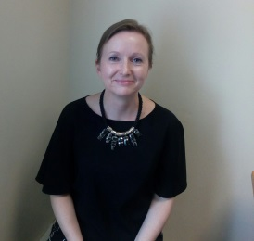
Is as Conamara Bairbre Ní Chuanaigh, áit a bhfuil sí ag obair mar Chléireach Airgeadais. Is iad Oisín ar an bPota agus Bláithín ar an bPota na chéad leabhra atá foilsithe aici.

Bairbre Ní Chuanaigh is from Connemara where she works as an Accounting Technician. Oisín ar an bPota and Bláithín ar an bPota are her first published works.

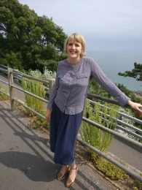
Sheena Dempsey

De bhunadh Chorcaigh Sheena Dempsey, maisitheoir a bhfuil mórán duaiseanna buaite aici.

An award winning illustrator who hails from Cork who now lives by the seaside in Southeast Kent with her partner Mick and their greyhound Sandy.

