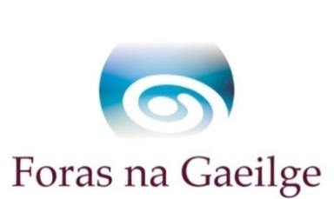

Step backwards for Irish in Ulster University a cause concern for Foras na Gaeilge

Foras na Gaeilge is greatly concerned about the reports in the media that the fulltime degree in Irish Language and Literature on the Belfast Campus of Ulster University is to be ended. This will have serious implications for third level Irish provision in Northern Ireland and for the promotion of Irish in general. If these reports ar true the fulltime Irish degree on the Belfast campus will be
discontinued and, as a result, there will no longer be fulltime Irish students during the day on the campus when the present cohort have completed their degrees in Irish. As well as this, opportunities at third level will be denied to students wishing to focus on Irish at third level in the greater Belfast area, which would have serious implications for the development of Irish in the city. This degree course is currently hugely popular and there are up to 60 enrolled fulltime on the University’s Belfast campus.

A report commissioned by Foras na Gaeilge shows that there is very strong all-island support for Irish-medium education and that this support has increased significantly in the north between 2001 (22%) and 2013 (48%) (Darmody & Daly, 2015). To foster this positive attitude and interest it is vital that there be continuous opportunities from level to level for students wishing to study Irish. Seán Ó Coinn, Deputy Chief Executive of Foras na Gaeilge, said, “With the Irish degree available at Ulster University in Belfast, Irish language organisations and the Irish language community can be sure that there will be 60 undergraduates available to the community to support their efforts on a continuous basis, and there will be a constant stream of gratuates with excellent Irish language skills available to work in the Irish language sector and in other sectors.”

Commenting on Foras na Gaeilge efforts in promoting the Irish language in the north, Seán Ó Coinn said, “Foras na Gaeilge has invested millions over the years on behalf of the Government in the development of the Irish language in the greater Belfast area, funding community groups, the Cultúrlann, Raidió Fáilte, Irish language organisations, drama, arts and events for young people. The continuous availability of Irish language graduates is vital if this investment is to come to full fruition for the Irish language at the community level in the future.”

Foras na Gaeilge will be raising the question with the University and with other interested parties in the coming days.

A copy of the report Dearcadh an Phobail i leith na Gaeilge (Darmody & Daly, 2015) is available at this link: http://www.esri.ie/publications/latest_publications/view/index.xml?id=4256

** Ends **

More information

Anna Davitt, Programme Manager: Communication, Marketing and Awareness

Tel: 087 6736175 Email: adavitt@forasnagaeilge.ie

