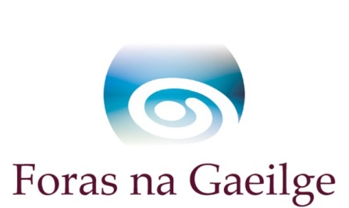

€4M approved by the North South Ministerial Council for
Irish Language Communities Scheme 2016 – 2020

Foras na Gaeilge welcomes applications from community organisations to the Irish Language Communities Scheme 2016 – 2020, which has been approved by the North South Ministerial Council on the 6 November. The revised scheme will replace the current round of the Irish Language Community Scheme, under which 19 groups are funded until June 2016. The scheme will provide a grant of up to €154,000/£124,500 for committees over a 4 year period and it aims to increase the number of communities receiving a grant from 19 groups to 26 groups under the new round of the scheme.

Through the scheme Foras na Gaeilge will fund a network of community based Irish language officers to be employed under the direction of local Irish language committees for four years from July 2016 to June 2020. These officers will have facilitation and networking duties, as well as duties in relation to the development of other institutions in which Irish will be used and promoted for the benefit of that community.

The changes to the Irish Language Community Scheme 2011-2013 arose out of a consultation process which reflected the central role of the Irish Language Development Officers in developing the Irish language in the community and the revised scheme aims to perpetuate development on a local and longterm basis.

Changes to the revised scheme include:

- The scheme will be focused on development and perpetuation of networks and institutions/bodies on a four year basis (extended from 3 years).
- There will be a maximum grant approved starting at €37,000 in year 1 and rising incrementally to €40,000 in year 4.
- New communities will be empowered to benefit from the scheme by increasing the number of possible grantees to a maximum of 26 successful applicants under the new round of the scheme. This is an increase of 37% on the number of grantees who will receive support through the new round of the scheme.
- Emphasis will be placed on sustainable development in the communities themselves which will empower groups to maintain ownership and oversight within their own target range and to ensure that there will be permanent outcomes as a result of the scheme funding.
- A maximum of 80% of the costs for a Development Officer’s pay will be available through the grant – successful applicants will have the choice of adding to this provision from their own sources.
- The Lead Organisation Glór na nGael will have a regional development and support role, sharing and encouraging good practice in projects funded through the Irish Language Communities Scheme through the network of 10 Development Officers which are part of this Lead Organisation’s staff. Glór na Gaeilge is the Lead Organisation responsible for the area of ‘Community and Economic Development’. As well as this, Glór na nGael will have a mentoring role supporting groups with the application process.

More information on the Irish Language Communities Scheme 2016 – 2020 is available on the Foras na Gaeilge website at www.gaeilge.ie/sceimeanna-maoinithe/ or by emailing spg@forasnagaeilge.ie.

Applications to the scheme will be accepted before the 17 December 2015 and the results of the scheme will be announced in April 2016.

Further Information:

Anna Davitt, Programme Manager: Communications, Marketing and Awareness
Tel: +353 (0)87 6736175 Email: adavitt@forasnagaeilge.ie

