Preaseisiúint
Leagan Béarla thíos / English version below
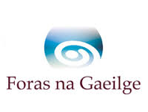
Bróisiúr dátheangach do thurais scoile foilsithe ag Páirc Tayto
An 27 Aibreán 2016
Tá ríméad ar Fhoras na Gaeilge go bhfuil an bróisiúr dátheangach Turais Scoile Pháirc Tayto 2016 / Tayto Park School Tours 2016 foilsithe ag Tayto Park le tacaíocht ó Fhoras na Gaeilge.
Ag fáiltiú roimh an tiomantas atá léirithe ag Tayto inniu, dúirt Príomhfheidhmeannach Fhoras na Gaeilge, Ferdie Mac an Fhailigh, go gcuirfidh ‘na turais deiseanna luachmhara úsáide ar fáil do pháistí scoile agus spreagfar iad leis an Ghaeilge a úsáid i dtimpeallacht spraíúil, thaitneamhach.’
Dúirt Niamh Reynolds, Bainisteoir Margaíochta, Páirc Tayto, ‘Tá lúcháir ar Pháirc Tayto bheith ag obair i gcomhpháirt le Foras na Gaeilge lenár mbróisiúr turas nua dátheangach do 2016 a chur ar fáil. Bhí an tacaíocht maidir le dearadh agus ábhar clóite an-luachmhar do bhranda Pháirc Tayto. Ba bhealach nuálach é feasacht ar an nGaeilge a mhéadú le linn turais scoile i bPáirc Tayto. Táimid tar éis spéis mhór agus méadú mór a fheiceáil i dturais scoile trí Ghaeilge mar gheall air. Tús maith, leath na hoibre!’
Is féidir teacht ar an mbróisiúr dátheangach ar shuíomh Tayto Park ar an nasc seo: http://www.taytopark.ie/schools-groups/school-tours
Tuilleadh eolais

Anna Davitt, Clárbhainisteoir: Cumarsáid, Margaíocht & Feasacht, Foras na Gaeilge
Teil: 0035387 673 6175
Ríomhphost: adavitt@forasnagaeilge.ie
Niamh Reynolds, Bainisteoir Margaíochta, Páirc Tayto
Teil: 003531 8351999
Ríomhphost: niamh.reynolds@taytopark.ie
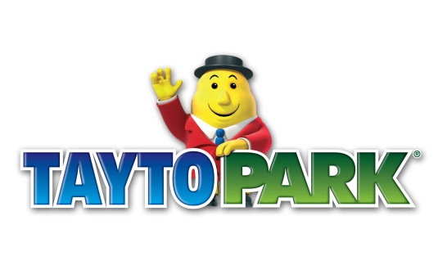
Press Release
Bilingual school tours brochure published by Tayto Park
27 April 2016
Foras na Gaeilge is delighted that Tayto Park has published Turais Scoile Pháirc Tayto 2016 / Tayto Park School Tours 2016 with support from Foras na Gaeilge.
Welcoming the dedication shown by Tayto today, the Chief Executive of Foras na Gaeilge, Ferdie Mac an Fhailigh, said that ‘the tours will provide valuable opportunities of use for school children and they will be encouraged to use Irish in a fun and enjoyable environment.’
Niamh Reynolds, Marketing Manager with Tayto Park, has said, ‘Tayto Park are delighted to be associated with Foras na Gaeilge and to have partnered with the organisation in the production of our new bilingual school tours brochure for 2016. The support on design and print work was invaluable to the Tayto Park brand. It was an innovative way for us to increase awareness of the Irish language among school tours in Tayto Park. We have seen a great interest and increase in school tours through Irish as a result. Tús maith, leath na hoibre! (A good start is half the work)’
The bilingual brochure is available on Tayto Park’s website on this link: http://www.taytopark.ie/schools-groups/school-tours

Further information

Anna Davitt, Programme Manager: Communications, Marketing & Awareness, Foras na Gaeilge
Teil: 0035387 673 6175
Email: adavitt@forasnagaeilge.ie
Niamh Reynolds, Marketing Manager, Tayto Park
Tel: 003531 8351999
Email: niamh.reynolds@taytopark.ie

