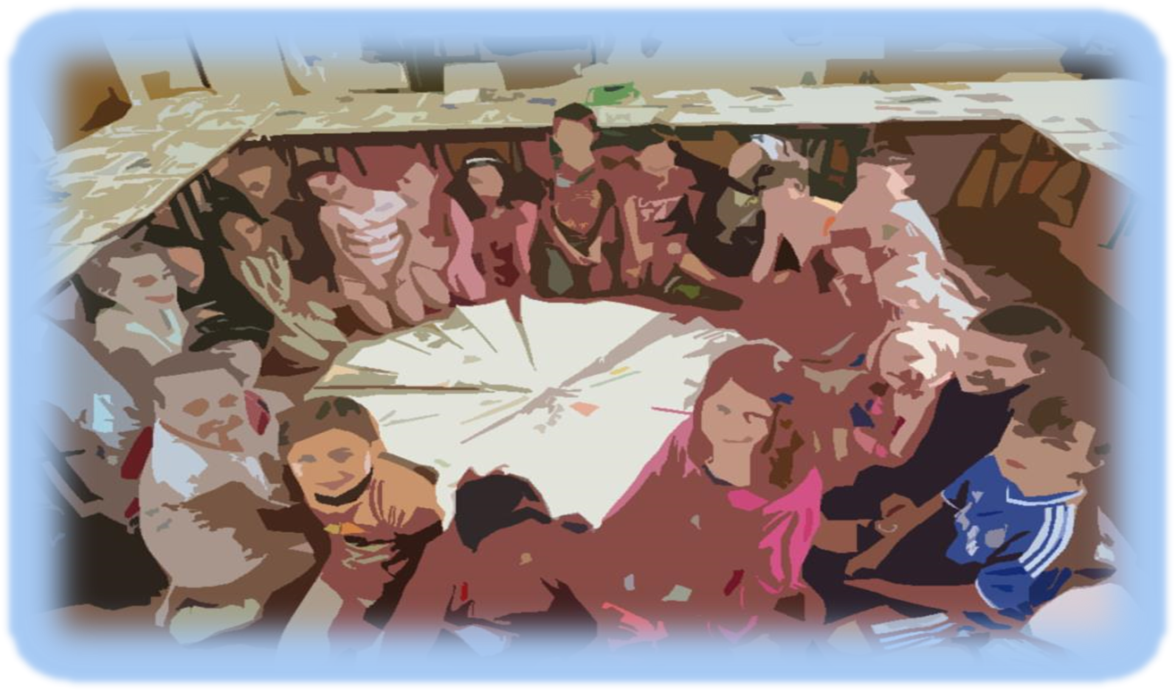
Foirm Iarratais
Uimhir Thagartha:
(Don oifig amháin)

Application Form



Scéim na gCampaí Samhraidh 2018
Summer Camp Scheme 2018

Campaí Samhraidh Trí Ghaeilge Don Aos Óg Lasmuigh den Ghaeltacht
(Campa 5 Lá – Uasmhéid Maoinithe €2,500/£1,750)

Irish Language Summer Camps for Young People Outside of the Gaeltacht
(5 Day Camp - Maximum Funding €2,500/£1,750stg.)

Caithfidh tú an fhoirm seo a chomhlánú go LEICTREONACH
You must fill this form ELECTRONICALLY

Spriocdháta: 12.00pm, Dé hAoine 23 Márta 2018
Deadline for applications: 12.00pm Friday 23 March 2018
Seicliosta Checklist

Dícháileofar an t-iarratas mura bhfuil gach rud ón seicliosta thíos curtha leis, nó mura dtagtar ar réiteach eile chun shástacht Fhoras na Gaeilge. Má cheapann tú nach mbaineann mír ón seicliosta leat, moltar duit teagmháil a dhéanamh le hoifigigh Fhoras na Gaeilge sula gcuireann tú an t-iarratas isteach. Tabhair faoi deara gur gá gach rud a chur ar fáil, fiú má cuireadh chuig Foras na Gaeilge roimhe iad.

The application will be disqualified if everything from the checklist below is not sent with it unless another agreement is reached to the satisfaction of Foras na Gaeilge. If you think that an item from the checklist does not pertain to you, you are advised to contact Foras na Gaeilge officers before you submit the application. Please note that everything must be supplied, even if previously submitted to Foras na Gaeilge.

- Cóip chrua den fhoirm iarratais, comhlánaithe agus sínithe mar is cuí | - hard copy of the application form, completed and signed as appropriate.
- Miondealú ar chostais – féach ceist ar an bhfoirm iarratais maidir le caiteachas an champa – is féidir leanúint ar leathanach breise más gá | - detailed breakdown of costs – see question on application form regarding camp expenditure – you can continue on an additional page if necessary;
- clár cuimsitheach d’imeachtaí an champa (féach ceist 20 ar an bhfoirm) | - a comprehensive programme of events for the camp (see question 20 on the form)
- polasaí maidir le cumhdach leanaí – cóip shínithe (fiú má cuireadh seo chuig Foras na Gaeilge cheana féin) | - child safeguarding policy – a signed copy (even if this has been previously sent to Foras na Gaeilge)
- polasaí árachais dliteanais phoiblí mar atá sonraithe i gCritéir Mhaoinithe na Scéime * | - public liability insurance policy as detailed in the Scheme Funding Criteria *
- bunreacht na heagraíochta nó meabhrán agus ailt (fiú má cuireadh seo chuig Foras na Gaeilge cheana féin) | - Organisation’s constitution / memorandum and articles (even if this has been previously sent to Foras na Gaeilge)
- deimhniú imréitigh cánach (ó eagraíochtaí a fhaigheann €10,000 nó níos mó ó Fhoras na Gaeilge sa bhliain airgeadais reatha) | - tax clearance certificate (from organisations receiving €10,000 or more from Foras na Gaeilge in the current financial year)
- ráiteas caiteachais is deireanaí sínithe agus dátaithe ag cisteoir agus rúnaí/cathaoirleach an choiste nó cuntais iniúchta | - most recent statement of expenditure signed and dated by treasurer and secretary/chairperson of committee or audited accounts
- ráiteas bainc is deireanaí in ainm na heagraíochta/an champa | - most recent bank statement in the name of the organisation/camp
- meastacháin neamhspleácha ar pháipéar sainchlóite do gach iarratas ar earraí/sheirbhísí mar seo a leanas:  - Suas go £1,000/€1,500 – 2 thairiscint ó bhéal,  - £1,000/€1,500 go £10,000/€15,000 – 3 thairiscint roghnaithe. | - independent quotes on headed paper for every application for goods/services as follows:  - Up to £1,000/€1,500 – 2 verbal quotations,  - £1,000/€1,500 to £10,000/€15,000 – 3 selected quotations.

* Mura bhfuil árachas an champa deimhnithe ag am an iarratais, glacfaimid le cóip d’árachas na bliana seo caite, nuair is cuí, mar aon le dearbhú scríofa agus síniú ón té atá freagrach as an gcampa ag cur in iúl go mbeidh árachas i bhfeidhm mar atá sonraithe i gCritéir na Scéime thuas roimh thús an champa. Ní mór cóip den pholasaí seo a sholáthar d’Fhoras na Gaeilge sula mbronnfar aon ghála den deontas.

* If insurance has not been confirmed at the time of the application, we will accept a copy of last year’s policy, where appropriate, along with written confirmation and a signature from the person responsible for the camp indicating that insurance will be in place as detailed in the Scheme Criteria above before the start of the camp. A copy of this policy must be provided to Foras na Gaeilge before any instalment of the grant is awarded.

Má tá aon cheist agat faoi aon ghné den seicliosta seo, déan teagmháil linn le do thoil.

If you have any queries on any aspect of this checklist, please contact us.

Uimhir Thagartha:
(don oifig amháin
Office use only)

Moltar duit na Treoirlínte a léamh go cúramach sula gcomhlánaíonn tú an fhoirm iarratais seo.

Níl cead ach iarratas amháin a dhéanamh ar son d’eagraíochta.

You are recommended to read the Guidelines carefully before completing this application form.

Only one application may be made on behalf of your organisation.

Deimhním go gcomhlíonann an eagraíocht critéir cáilithe uile na scéime (cuir tic)
I confirm that the organisation fulfils all qualifying criteria of the scheme (enter tick)

- Ainm na hEagraíochta
Name of Organisation
- Ainm an Champa
Name of Camp
- Ainm Teagmhála Contact Name
- Seoladh agus éirchód / cód poist an teagmhálaí
Contact address and eircode / postcode for the applicant

- Uimhir fóin
Telephone number

Fón póca
Mobile number

- Ríomhphost
E-mail
- Toghcheantar Dála/Tionóil
Dáil/Assembly electoral
district

(a mbeidh na himeachtaí ar siúl - féach Aguisín 3)
(where the events will take place. See Appendix 3)

8. Toghlimistéar áitiúil (comhairle contae/ cathrach)
Local electoral area (County/ city council)

(a mbeidh na himeachtaí ar siúl - féach Aguisín 3)
(where the events will take place See Appendix 3)

9. Uimhir chláraithe chánach
Uimhir charthanachta
Tax reference number
Charity number

10. Líon laethanta (cuir tic) Number of days (enter tick):

Deimhním gur campa 5 lá atá ann agus tuigim gur €2,500/£1,750 an t-uasmhéid maoinithe atá ar fáil

I confirm that it is a 5 day camp and understand that maximum funding of €2,500/£1,750 is available

11. Dátaí an champa ó from _____________ go to _____________
Dates of camp

12. Costas iomlán an champa
Total cost of camp €/£ __________________

13. Méid an deontais atá á lorg ó Fhoras na Gaeilge
Amount of grant sought from Foras na Gaeilge €/£ _________________

-------------------------------------------------------------------------------------------------------------------------------------

Don oifig amháin Office use only:

Síniú: __________________________

Dáta: ________________________
14. Seoladh an champa
Address of camp

15. Uimhir theagmhála an champa
Camp contact number

16. Áiseanna ar fáil don champa

Facilities available to the camp

17 Líon daoine óga lena bhfuiltear ag súil
Number of young people expected

18 Uaireanta sa lá

Am tosaithe Start time ________
Am críochnaithe End time __________

Líon Uaireanta sa lá Number of hours per day __________

(4.5 uair ar a laghad)
Hours per day
(4.5 hours at least)

19 Ar smaoinigh sibh ar aon dóigh eile leis an scéim seo a chur i bhfeidhm?
Cén fáth gur seo an rogha is fearr do do cheantar?
Did you consider any other ways to run this scheme?
Why is this the best choice for your area?

20 Clár Imeachtaí don champa Programme of Activities for camp

Tá an campa seo ag freastal ar dhaoine óga le Gaeilge nó daltaí gaelscoile

This camp caters for young people with Irish or gaelscoil pupils

Tá an campa seo ag freastal ar dhaoine óga atá ag foghlaim nó ar bheagán Gaeilge

This camp caters for young people who are learning Irish or have little Irish

Cuir tic sa dá bhosca má tá meascán ann Tick both boxes if there is a mix

Ní mór na nithe seo a leanas a chur san áireamh do gach imeacht agus gníomh:
Each of the following must be included for each event and activity:
- Sonraí an imeachta/ghnímh Details of event/activity
- Sprioc foghlama (i.e. cad é a bheas foghlamtha ag an duine óg) Learning aim (i.e. what will the young person have learned)

Liostáil imeachtaí/gníomhaíochtaí uile an champa agus na torthaí foghlamtha a bhaineann leo.
List each event/activity of the camp and the learning intentions which relate to them.

Imeacht/Gníomh  Event/Activity | Sprioc Foghlamtha  Learning Aim

Cuir síos ar thuras/thurais atá beartaithe agus tabhair sonraí faoin eispéireas teanga a bheidh ag na daoine óga mar aon leis na deiseanna foghlama agus labhartha a bheidh acu. Moltar duit a oiread sonraí agus is féidir a thabhairt anseo.
Describe planned trip/trips and give details of the language experience the young people will have as well as the opportunities for learning and speaking they will have. You are recommended to give as much detail as possible here.

Ní mhaoineofar aon turas a mheastar nach gcuirfidh le deiseanna foghlama agus labhartha na ndaoine óga.
Funding will not be provided for any trip where it is deemed that it will not add to the young people’s learning and speaking opportunities.

Ioncam agus caiteachas réamh-mheasta iomlán an champa
Projected overall income and expenditure for camp

21 Caiteachas Expenditure

Cur síos ar an gcaiteachas  Description of expenditure | Miondealú  Ní mór miondealú a thabhairt ar na príomhfhigiúirí – i.e. ráta in aghaidh na huaire don teagascóir/ceannaire, líon uaireanta, líon laethanta etc.  Breakdown  A breakdown of the main figures must be given – i.e. rate per hour for tutor/leader, number of hours, number of days etc. |  |  | Costas iomlán réamh-mheasta  Total projected Cost | Deontas atá á lorg ó Fhoras na Gaeilge  Grant requested from Foras na Gaeilge
Teagascóirí Teachers  (€28/£20 uasmhéid san uair)  Max €28/£20 per hour | Líon uaireanta Number of hours | Lion teagascóirí Number of tutors | Iomlán total
Ceannairí Leaders
(€14/£10 uasmhéid san uair)
Max €14/£10 per hour
Cíos Rent

Árachas Insurance

Turas Trip

Trealamh Equipment

Áiseanna Facilities

Aon chaiteachas eile (tabhair sonraí le do thoil)
Any other expenditure (please provide details)
Iomlán Total

NB, ní cheadaítear aon íocaíochtaí le hairgead tirim NB, payments in cash are not permitted
22 Ioncam Income

Táille in aghaidh an pháiste don champa:  Fee per child for camp: | €/£
Tabhair sonraí fosta faoi lacáistí ar bith:  Please also give details of any discounts: | €/£

€/£
A: Iomlán a bhfuiltear ag súil leis ó tháillí
Total expected from fees:

B: Maoiniú ó fhoinsí eile
€/£
Funding from other sources:

Ainm an mhaoinitheora eile

Name of other funder:

Sonraí an mhaoinithe eile - iarrtha/ceadaithe/faighte
Details of other funding – requested/approved/received
(scrios an ceann nach n-oireann delete as appropriate)

Ioncam (A+B)
€/£
Income (A+B)

Méid an deontais atá á lorg ó Fhoras na Gaeilge
€/£
Amount of grant sought from Foras na Gaeilge

NB ní féidir le grúpaí maoiniú a lorg ó Fhoras na Gaeilge ach leis an difear a chlúdach idir caiteachas agus ioncam, go suim nach mó ná €2,500/£1,750.
NB groups may request funding from Foras na Gaeilge only to cover the difference between expenditure and income, to a limit of €2,500/£1,750.

23 Léirigh, le do thoil, aon chomhoibriú atá ar siúl ag an eagraíocht le grúpaí eile
maidir le heagrú an champa.
Please illustrate any collaboration that the organisation is carrying out with other groups in relation to organising the camp.

24. An bhfuil an eagraíocht ag fáil aon mhaoinithe eile ó Fhoras na Gaeilge ón 1ú Eanáir 2018?
Is the organisation receiving any other funding from Foras na Gaeilge since 1st January 2018?

Cuir tic sa bhosca cuí Please tick the appropriate box Tá Yes □ Níl No □

Má tá, tabhair sonraí If yes give details:

Ainm an tionscadail  Name of project | Uimhir thagartha  Reference number | Méid an deontais £/€  Amount of grant £/€

25. Cumhdach Leanaí Child Protection
Dearbhaím thar ceann na stiúrthóirí go mbeidh gach ball foirne a bheidh ag plé leis na daoine óga le linn an imeachta/na n-imeachtai cáilithe mar is cuí agus go mbeidh grinnfhiosrúchán déanta air. (Cuir tic sa bhosca)

I confirm on behalf of the camp’s directors that a all staff members dealaing with youths during the event will be fully qualified and that each youth leader will be vetted (tick the box)

Dearbhaím I confirm □

26 Dáta is deanaí a rinneadh athbhreithniú ar an pholasaí um chumhdach leanaí:____________
The most recent date that the child protection policy was reviewed: __________

27. An bhfuil d’eagraíocht cláraithe le AccessNI nó le scátheagras (ó thuaidh)? Tabhair sonraí le do thoil.
Is your organisation registered with AccessNI or with an umbrella organisation (in Northern Ireland) ? Please provide details.

28. Taithí ar eagrú campaí samhraidh, Ní gá gur campa Gaeilge atá i gceist.
(úsáid bileog eile más gá)
Experience of organising summer camps. Not necessarily an Irish language camp. (use another page if necessary)
□ Is é seo ár gcéad bhliain This is our first year
□ 1-2 bhliain 1-2 years
□ 3-4 bliana 3-4 years
□ 5+ bliana / 5+ years

29. Stiúrthóirí/Coisteoirí
Directors/Committee Members

Ainm Name | Ról Role | Taithí Experience

30. An bhfuil coimhlint leasa ag aon bhall foirne de chuid Fhoras na Gaeilge nó aon chomhalta boird de chuid Fhoras na Gaeilge i leith an iarratais seo? Má tá tabhair sonraí le do thoil.
Does any member of staff or a board member of Foras na Gaeilge have a conflict of interests regarding this application? If yes, please give details.

□Tá Yes □ Níl No

Má tá If yes:

Ainm an duine
Name of person:____________________________________________________

31. Cá háit ar chuala tú faoin scéim seo?
Where did you hear about this scheme?

DEARBHÚ DECLARATION

Ní ghlacfar le hiarratas ar bith gan an dearbhú seo a bheith sínithe ag an teagmhálaí, ag coisteoir agus ag finné neamhspleách (duine gairmiúil nach ball/fostaí den eagraíocht agus nach gaol é/í).

Dearbhaímid go bhfuil an t-eolas atá san iarratas seo cruinn ceart. Tuigimid go ndícháileofar an t-iarratas má tá aon eolas míchruinn tugtha.

No application will be accepted without this declaration signed by the contact, a committee member and an independent witness (a professional who is not a member/employee of the organisation or a relative).

We declare that the information in this application is accurate and correct. We understand that the application will be disqualified if any inaccurate information is given

Teagmhálaí Contact

Síniú | Signature
Dáta | Date
Stádas san eagraíocht | Status in organisation

Committee Member Coisteoir

Ainm i mbloclitreacha | Name in block capitals
Síniú | Signature
Dáta | Date
Stádas san Eagras | Status in organisation

Finné Neamhspleách Independent Witness

Ainm i mbloclitreacha | Name in block capitals
Gairm | Profession
Uimhir ghutháin | Tel. No
Síniú | Signed
Dáta | Date

Sonraí Teagmhála:
Contact Details:

Campaí Samhraidh Summer Camps
Foras na Gaeilge
63-66 Sráid Amiens
BAILE ÁTHA CLIATH 1
D01 H275

Campaí Samhraidh Summer Camps
Foras na Gaeilge
Teach an Gheata Thiar
2-4 Sráid na Banríona
BÉAL FEIRSTE
BT1 6ED

Baile Átha Cliath: 00353 1 639 8400

Béal Feirste: 028 9089 0970 / 048 9089 0970 (ó Thuaidh)
Ríomhphost Email: oideachas@forasnagaeilge.ie

www.forasnagaeilge.ie

 |  |  | 

Beidh oifigigh Fhoras na Gaeilge sásta aon cheist atá agat maidir leis an bhfoirm iarratais a fhreagairt roimh an spriocdháta.

Foras na Gaeilge officers will be happy to answer any question you have regarding the application form prior to the deadline.

CRÍOCH END

