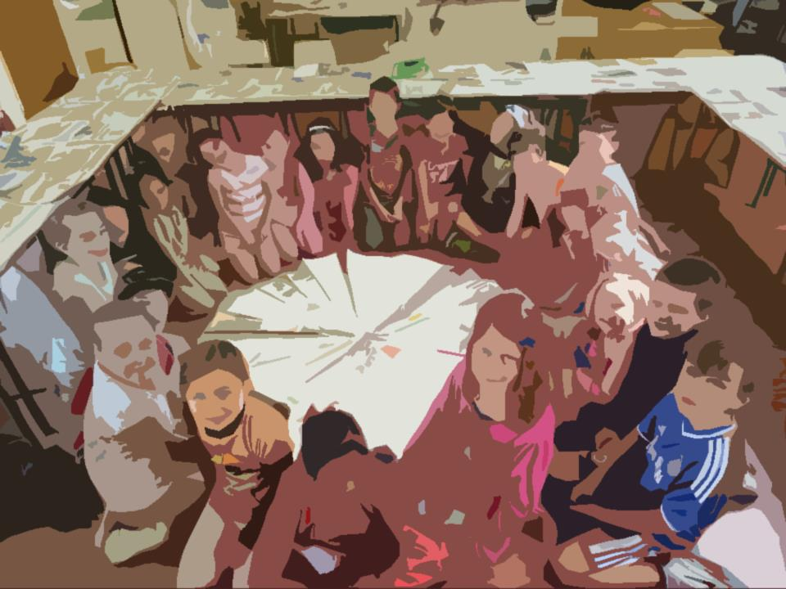
Foirm Iarratais
Uimhir Thagartha:
(Don oifig amháin)
(Office use only)

Application Form

Scéim na nImeachtaí Óige

Imeachtaí le linn na scoilbhliana
Meán Fómhair 2018 - Meitheamh 2019
(Uasmhéid Maoinithe ar fáil €5,000/£3,500)

Caithfidh tú an fhoirm seo a chomhlánú go LEICTREONACH

Spriocdháta: 12.00pm, Dé hAoine, 20 Aibreán 2018

Youth Events Scheme

Events during the school year
September 2018 - June 2019
(Maximum Funding Available €5,000 / £3,500)

You must complete this form ELECTRONICALLY

Deadline: 12.00pm, Friday, 20th April 2018

Beidh oifigigh Fhoras na Gaeilge sásta aon cheist atá agat maidir leis an bhfoirm iarratais a fhreagairt roimh an spriocdháta.

Foras na Gaeilge officers will be happy to answer any question you have regarding the application form prior to the deadline.

Seicliosta Checklist

Dícháileofar d’iarratas mura bhfuil gach rud ón seicliosta thíos curtha leis, ach amháin má thagtar ar réiteach eile chun shástacht Fhoras na Gaeilge.

Má shíleann tú nach mbaineann aon rud ar an seicliosta leat, molaimid duit teagmháil a dhéanamh le hoifigigh Fhoras na Gaeilge sula gcuirfidh tú an t-iarratas isteach.

Tabhair faoi deara go gcaithfidh tú gach rud a chur ar fáil leis an iarratas seo, fiú má tá siad curtha chuig Foras na Gaeilge roimhe.

Your application will be disqualified if everything from the checklist below is not sent with it, unless an agreement is reached to the satisfaction of Foras na Gaeilge.

If you think that any item from the checklist does not pertain to you, we advise you to contact Foras na Gaeilge officers before you submit the application.

Please note that you must supply every item, even if previously submitted to Foras na Gaeilge.

- cóip chrua den fhoirm iarratais, comhlánaithe agus sínithe mar is cuí  - miondealú síos ar chostais – féach ceist ar an bhfoirm iarratais maidir le caiteachais an imeachta/na n-imeachtaí – is féidir leanúint ar leathanach breise más gá  - clár cuimsitheach don imeacht/do na himeachtaí  - polasaí um chumhdach leanaí – cóip shínithe (fiú má cuireadh seo chuig Foras na Gaeilge cheana féin)  - polasaí árachas dliteanais phoiblí mar atá sonraithe i gCritéir Mhaoinithe na Scéime* (fiú má cuireadh seo chuig Foras na Gaeilge cheana féin)  - bunreacht na heagraíochta nó meabhrán agus ailt na heagraíochta  - ráiteas caiteachais is deireanaí sínithe agus dátaithe ag cisteoir agus rúnaí/cathaoirleach an choiste nó cuntais iniúchta  - deimhniú imréitigh cánach (ó eagraíochtaí a fhaigheann €10,000 nó níos mó ó Fhoras na Gaeilge sa bhliain airgeadais reatha)  - ráiteas bainc is deireanaí in ainm na heagraíochta  - meastacháin neamhspleácha ar pháipéar sainchlóite do gach iarratas ar earra/ábhar/sheirbhís mar seo a leanas:  - suas go £1,000/€1,500 – 2 thairiscint bhéil,  - £1,000/€1,500 go £10,000/€15,000 – 3 thairiscint roghnaithe. | - hard copy of the application form, completed and signed as appropriate.  - detailed breakdown of costs – see question on application form regarding event(s) expenditure – you can continue on an additional page if neccessary  - a comprehensive programme for the event(s)  - child safeguarding policy – a signed copy (even if this has been previously sent to Foras na Gaeilge)  - public liability insurance as detailed in the Scheme Funding Criteria*(even if this has been previously sent to Foras na Gaeilge)  - the organisation’s constitution or memorandum and articles  - most recent statement of expenditure signed and dated by treasurer and secretary/chairperson of committee or audited accounts  - tax clearance certificate (from organisations receiving €10,000 or more from Foras na Gaeilge in the current financial year)  - most recent bank statement in the name of the organisation  - independent quotes on headed paper for every application for goods/services as follows:  - up to £1,000/€1,500 – 2 verbal quotations,  - £1,000/€1,500 to £10,000/€15,000 – 3 selected quotations.

* Mura bhfuil árachas deimhnithe ag am an iarratais, glacfaimid le cóip d’árachas na bliana seo caite, nuair is cuí, mar aon le dearbhú scríofa agus síniú ón té atá freagrach as na himeachtaí go mbeidh árachas in áit mar atá sonraithe i gCritéir na Scéime roimh thús na n-imeachtaí. Caithfidh sibh cóip den pholasaí seo a chur chuig Foras na Gaeilge sula mbronnfar an deontas.

* If insurance has not been confirmed at the time of the application, we will accept a copy of last year’s policy, where appropriate, along with a writtendeclaration and a signature from the person responsible for the events that insurance, as detailed in the Scheme Criteria, will be secured before the events begin. You must provide a copy of the policy to Foras na Gaeilge before the grant will be awarded.

Má tá aon cheist agat faoi aon ghné den seicliosta seo, déan teagmháil linn le do thoil.
If you have any queries on any aspect of this checklist, please contact us.

ADMHÁIL RECEIPT

Molaimid duit na Treoirlínte a léamh go cúramach sula gcomhlánóidh tú an fhoirm iarratais seo. Tá roinnt athruithe déanta sa scéim seo i mbliana. Níl cead ach iarratas amháin a dhéanamh ar son eagraíocht ar bith.

We recommend you read the Guidelines carefully before completing this application form. Several changes have been made to this scheme this year. Only one application may be submitted per organisation.

Deimhním go gcomhlíonann an eagraíocht critéir cháilitheacha uile na scéime (cuir tic)
I confirm that the organisation fulfils all qualifying criteria for the scheme (enter tick)

1. Ainm na heagraíochta
Name of organisation
2. Ainm teagmhála
Contact name
3. Seoladh agus cód poist / Éirchód an duine teagmhála
Address and post code / Eircode of the contact person

4. Uimhir fóin
Telephone number

Fón póca
Mobile number
5. Ríomhphost
E-mail
6. Seoladh agus uimhir theagmhála
an ionaid do na himeachtaí
Address and Contact number for the centre in which the activities will take place.
7. a) Toghcheantar Dála/Tionóil
Dáil/Assembly electoral district
b) Toghlimistéar áitiúil
Local electoral area

(a mbeidh an campa ar siúl)
(where the camp will take place)
8. Uimhir chláraithe chánach
Tax registration number
Uimhir charthanachta
Charity number
9. Ainm na n-imeachtaí
Name of events

10. Dátaí na n-imeachtaí
Lá agus am
Dates of events
Day and time

m.sh. Gach Luan 7-9in ó 01.09.18 go 30.06.19

e.g. Every Monday 7-9 from 01.09.18 to 30.06.19
11. Costas iomlán an tionscadail
Total cost of project
12. Méid an deontais atá á lorg ó Fhoras na Gaeilge:
Amount of grant sought from Foras na Gaeilge:

13. Stiúrthóirí/coisteoirí | Directors/committee members

Ainm | Name | Ról | Role | Taithí nó scileanna cuí |  Experience or relevant skills

14. Foireann do na himeachtaí | Staff for the events

Ainm | Name | Ról | Role | Taithí | Experience

15. Cumhdach Leanaí | Child Protection

Dearbhaím thar ceann na stiúrthóirí go mbeidh gach ball foirne a bheidh ag plé leis na daoine óga le linn an imeachta/na n-imeachtaí cáilithe mar is cuí agus go mbeidh grinnfhiosrúchán déanta air. (Cuir tic sa bhosca)
I confirm on behalf of the directors that every staff member who will be dealing with the young people during the event(s) will be appropriately qualified and will be vetted. (Tick the box)

Dearbhaím I confirm

Dáta is deanaí a rinneadh athbhreithniú ar an pholasaí:
The last date the policy was revised:

16. An bhfuil d’eagraíocht cláraithe le Access NI nó le scátheagras (ó thuaidh amháin)? Tabhair sonraí le do thoil.

Is your organisation registered with Access NI or with an umbrella organisation (in Northern Ireland only)?
Please give details.

17. Cé mhéad bliain de thaithí atá ag do ghrúpa ag eagrú imeachtaí do dhaoine óga?  Cuir tic sa bhosca cuí.  How many years experience does your group have organising events for young people?  Tick the appropriate box. | Is é seo ár gcéad bhliain  This is our first year  1-2 bhliain 1-2 years  3-4 bliana 3-4 years  5+ bliana / 5+ years

18. Ar smaoinigh sibh ar aon dóigh eile leis an scéim seo a chur i bhfeidhm? Cén fáth gur seo an rogha is fearr do do cheantar?
Did you consider any other ways to run this scheme? Why is this the best choice for your area?

19. Conas a chuirfidh na himeachtaí seo le deiseanna úsáide Gaeilge do dhaoine óga?
How will these events add to young people’s opportunities to use the Irish language?

20. An bhfuil imeachtaí den chineál seo ar siúl sa cheantar cheana? Cuir tic sa bhosca chuí.
Are there events of this type alreadytaking place in the area? Tick the appropriate box.

Tá

Níl

Má tá, inis dúinn faoina himeachtaí seo (ainm an ghrúpa, ceantar etc.) agus inis dúinn an dóigh a ndéanfaidh sibh comhoibriú leis na himeachtaí eile seo le cur le deiseanna úsáide Gaeilge do dhaoine óga

If so, please tell us about these events (name of group, area etc.) and tell us how you will co-operate with these other events to increase the opportunities for young people to use Irish

Má tá, cad é mar a chuirfidh na himeachtaí luaite ar an bhfoirm seo leis na himeachtaí atá ann cheana féin do na daoine óga sa cheantar?

If so, how will the events listed on this form add to the current events in your area for young people?

21. Áiseanna atá ar fáil san ionad do na himeachtaí
Facilities available at the centre for the events

22. Líon iomlán daoine óga lena bhfuil sibh ag súil le linn thréimhse na scéime
Total expected number of young people during the duration of the scheme

23. Táille an pháiste in aghaidh an tseisiúin
Fee per child per session

24. Cé air a bhfuil an clár imeachtaí dírithe?  Cuir tic sa bhosca cuí. Má tá meascán ann, cuir tic sa dá bhosca.  Who is the events programme focused on?  Tick the appropriate box. If there is a mixture, tick both boxes. | Tá an scéim seo ag freastal ar dhaoine óga le Gaeilge agus daltaí gaelscoile  This scheme caters for young people with Irish and Gaelscoil pupils  Tá an scéim seo ag freastal ar dhaoine óga atá ag foghlaim nó atá ar bheagán Gaeilge  This scheme caters for young people who are learning or who have little Irish

25. Clár Imeachtaí | Programme of Events

Lá  (laethanta)  Day  (days) | Dáta(í)  Date(s) | Am  Time | Imeacht  Event | Cuspóir foghlamtha  Learning intention | Toradh (torthaí) beartaithe  Proposed outcome(s)

Is féidir leanúint ar leathanach eile más gá.
Má bhíonn aon athrú ar an gclár ama seo, ó thaobh laethanta, dátaí, ná imeachtaí de, nó líon na ndaoine óga, caithfidh do ghrúpa sin a aontú i scríbhinn le Foras na Gaeilge.

Continue on additional page if necessary.
If there are any changes in this programme, as to days, dates or events, or number of young people, your group must agree this in writing with Foras na Gaeilge.

26. Costas iomlán réamh-mheasta na n-imeachtaí | Projected total cost of Events

Cur Síos ar an gcaiteachas  Description of expenditure | Miondealú*  Ní mór miondealú ar na príomhfhigiúirí a thabhairt – i.e. ráta in aghaidh na huaire don teagascóir/cheannaire, líon uaireanta, líon laethanta etc.  Break down  A breakdown of the main figures must be given – i.e. rate per hour for tutor/leader, number of hours, númber. of days etc. | Costas iomlán tuartha  Total predicted cost | Deontas iarrtha ó Fhoras na Gaeilge do 2018  Grant requested from Foras na Gaeilge for 2018 | Deontas iarrtha ó Fhoras na Gaeilge do 2019  Grant requested from Foras na Gaeilge for 2019
Teagascóirí
Tutors

*Cuir san áireamh an costas in aghaidh an tseisiúin agus líon na seisiún
*Include cost per session and number of sessions
Ceannairí
Leaders

*Cuir san áireamh an costas in aghaidh an tseisiúin agus líon na seisiún
*Include cost per session and number of sessions

Cíos
Rent
Árachas
Insurance
Turas
Trip

*Tabhair faoi deara nach dtugann Foras na Gaeilge maoiniú do thurais imchónaithe
*Please note Foras na Gaeilge do not fund residential trips
Trealamh
Equipment
Áiseanna
Resources

*Ní mór d’áiseanna ar bith atá maoinithe ag Foras na Gaeilge fanacht i seilbh an choiste
*Any resources funded by Foras na Gaeilge must remain in the possession of the committee.

Aon chaiteachas eile (tabhair sonraí le do thoil)
Any other expenditure (please provide details)
Iomlán Total

27. An bhfuil an eagraíocht ag fáil aon mhaoiniú eile ó Fhoras na Gaeilge ón 1 Eanáir 2018 nó an bhfuil iarratas déanta agaibh?
Is the organisation receiving any other funding from Foras na Gaeilge since 1st January 2018 or have you made an application?

Tá

Níl

Má tá If yes

Ainm an tionscadail
Name of project

Stádas, i.e. curtha isteach/faighte
Status i.e. applied for/granted

Uimhir thagartha (más cuí)
Ref. number (if appropriate)

Méid an mhaoinithe atá iarrtha/ bronnta
Amount of funding requested/granted

28. Foinsí eile maoinithe don tionscadal seo (más ann dóibh):
Other sources of funding for this project (if they exist):

Ainm agus seoladh an mhaoinitheora
Name and address of funder

Uimhir theagmhála an mhaoinitheora
Contact number of funder

Méid an mhaoinithe iarrtha/ceadaithe/faighte
Amount of funding applied for/approved/received

29. An bhfuil coimhlint leasa ag aon bhall foirne de chuid Fhoras na Gaeilge nó aon chomhalta boird de chuid Fhoras na Gaeilge i leith an iarratais seo? Má tá tabhair sonraí le do thoil.
Does any member of staff or board member of Foras na Gaeilge have a conflict of interests regarding this application? If yes, please give details.

Tá

Níl

Ainm an duine:
Name of person:

Eolas:
Information:

30. Cá háit ar chuala tú faoin scéim seo?
Where did you hear about this scheme?

DEARBHÚ DECLARATION

Ní ghlacfar le hiarratas ar bith gan an dearbhú seo a bheith sínithe ag an teagmhálaí, ag coisteoir agus ag finné neamhspleách (duine gairmiúil nach ball/fostaí den eagraíocht agus nach gaol é/í).

Dearbhaímid go bhfuil an t-eolas atá san iarratas seo cruinn ceart. Tuigimid go ndícháileofar an t-iarratas má tá aon eolas míchruinn tugtha.

No application will be accepted without this declaration signed by the contact, a committee member and an independent witness (a professional who is not a member/employee of the organisation or a relative).

We declare that the information in this application is accurate and correct. We understand that the application will be disqualified if any inaccurate information is given

Teagmhálaí Contact

Síniú | Signature
Dáta | Date
Stádas san eagraíocht | Status in organisation

Committee Member Coisteoir

Ainm i mbloclitreacha | Name in block capitals
Síniú | Signature
Dáta | Date
Stádas san Eagras | Status in organisation

Finné Neamhspleách Independent Witness

Ainm i mbloclitreacha | Name in block capitals
Gairm | Profession
Uimhir ghutháin | Tel. No
Síniú | Signed
Dáta | Date

Sonraí Teagmhála
Contact Details

Scéim na nImeachtaí Óige Youth Events Scheme
Foras na Gaeilge
63-66 Sráid Amiens
Baile Átha Cliath 1
D01 H275

Scéim na nImeachtaí Óige Youth Events Scheme
Foras na Gaeilge
Teach an Gheata Thiar
2-4 Sráid na Banríona
BÉAL FEIRSTE
BT1 6ED

Baile Átha Cliath Dublin: 00353 1 639 8400

Béal Feirste Belfast: 028 9089 0970 / 048 9089 0970

Ríomhphost E-mail: oideachas@forasnagaeilge.ie

www.forasnagaeilge.ie

