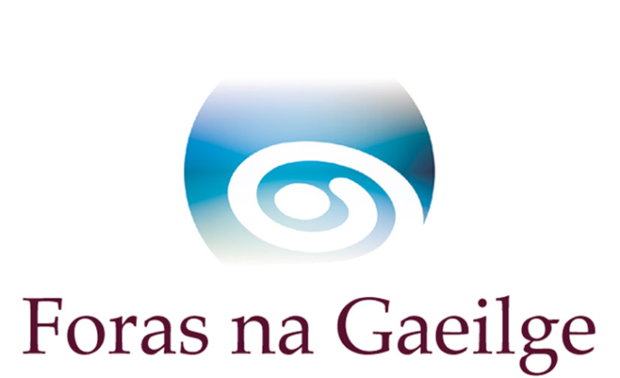

Scéim Miondeontas Cholmcille  le haghaidh tionscnamh nó comhpháirtíocht le hAlbain a chur chun cinn  Uasmhéid maoinithe ar fáil €1,800/£1,566  Spriocdháta meán lae an 10 Nollaig 2019  Cúlra  Is comhpháirtíocht é Colmcille idir Foras na Gaeilge in Éirinn agus Bòrd na Gàidhlig in Albain. Tá aidhm ag Colmcille caidreamh agus comhoibriú a chothú idir cainteoirí Ghaeilge na hÉireann agus cainteoirí Ghaeilge na hAlban, agus an dá phobal teanga a neartú.  Tá trí scéim maoinithe ag Colmcille:  - An scéim miondeontas le taighde a dhéanamh agus le comhthionscnaimh a phleanáil  - An scéim deontas le tionscadail a mhaoiniú (príomhscéim deontas Cholmcille)  - An scéim sparánachtaí le cuidiú le daoine Gaeilge na hAlban a fhoghlaim  Má tá tú ag iarraidh tionscnamh a fhorbairt le comhpháirtí in Albain, nó a bhainfeas le Gaeilge na hAlban, tá an scéim miondeontas seo (scéim 1 thuas) ann le cuidiú le comhthionscnaimh agus comhpháirtíocht a fhorbairt. Nuair a bheidh an chomhpháirtíocht agus an plean tionscnaimh aontaithe faoin scéim miondeontas seo, is féidir iarratas a dhéanamh ar Scéim Deontas Cholmcille (scéim 2 thuas, príomhscéim deontas Cholmcille), a thugann leibhéal tacaíochta níos airde, má bhíonn sin de dhíth.  Má tá spéis agat iarratas a dhéanamh gabh chun cainte le hoifigigh Cholmcille ag Foras na Gaeilge sula líonfaidh foirm iarratais na scéime.  Treoir d’iarratasóirí ar Scéim Miondeontas Cholmcille  - An féidir liom cur isteach ar an scéim ?  Tá an scéim oscailte do:  - eagraíochtaí in Éirinn agus in Albain atá ag iarraidh tionscnamh a fhorbairt le comhpháirtí sa tír eile  - eagraíochtaí atá ag cuardach comhpháirtí nó ag iarraidh comhpháirtíocht a dhéanamh  - duine aonair atá in ann tionscnamh comhpháirtíochta idir Éire agus Albain a chur i bhfeidhm le comhpháirtí sa tír eile:  - a mbeidh toradh fadtéarmach air  - a rachaidh chun leas mhórphobal Ghaeilge na hÉireann agus/nó Ghaeilge na hAlban  - An gá dom miondeontas a fháil roimh chur isteach ar phríomhscéim deontas Cholmcille ?  Ní gá. Is deis é seo comhpháirtíocht láidir a bhunú roimh chur isteach ar phríomhscéim deontas Cholmcille, má cheaptar go mbeadh sin fiúntach.  - Cén cineál costais is féidir a chur san áireamh?  - Taisteal, lóistín agus cothú atá riachtanach le plean comhpháirtíochta a chur le chéile a léiríonn luach ar airgead agus atá réamhaontaithe le Foras na Gaeilge  - Ceardlanna nó oiliúint leis an tionscnamh a fhorbairt  - Gníomhaíocht ar bith eile a bheadh fóirsteanach i dtuairim Fhoras na Gaeilge agus réamhaontaithe le Foras na Gaeilge  - Cén obair atá le déanamh?  - Taighde riachtanach  - Plean tionscnaimh a chomhaontú le comhpháirtí in Albain, nó in Éirinn más páirtí in Albain an t-iarratasóir  - Plean le haghaidh úsáid teanga a aontú le gur féidir Gaeilge na hÉireann agus Gaeilge na hAlban a úsáid  - Cad é mar a dhéanfaidh Foras na Gaeilge measúnú ar iarratais?  Déanfaidh Foras na Gaeilge measúnú ar iarratais de réir na gceisteanna seo:  - An bhfuil comhpháirtí agat in Albain, nó teagmháil déanta le comhpháirtí féideartha? Má tá, tabhair sonraí le do thoil (ainm, cur síos, seoladh, ríomhphost agus uimhir fóin)  - Cén toradh is mian leat a bhaint amach leis an mhiondeontas seo?  - Cad iad na spriocanna atá agat leis an obair seo faoin scéim miondeontas?  - Cén taighde atá déanta agat go dáta agus cad iad torthaí an taighde?  - Tabhair cuntas ar an obair atá le déanamh agus sceideal  - Cén uair ba cheart an t-airgead a bheith caite ?  Ba cheart an t-airgead a bheith caite agus an tuairisc a bheith istigh roimh dheireadh na bliana má dhéantar an t-iarratas idir Eanáir agus Meitheamh. Má dhéantar an t-iarratas idir Iúil agus Nollaig, is cóir an t-airgead a bheith caite agus an tuairisc  a bheith istigh roimh shé mhí ón dáta atá ar an litir thairisceana.  - Cén uair a bheidh cinneadh ar fáil?  Tá súil againn cinneadh a bheith ar fáil taobh istigh de shé seachtaine i ndiaidh an t-iarratas a bheith faighte againn. I gcás eagraíochtaí a bhfuil maoiniú suntasach acu ó Fhoras na Gaeilge cheana féin in 2018/2019, is féidir go mbeidh próiseas níos faide ann. | Colmcille Small Grants Scheme  for promoting an initiative or a partnership with Scotland  Maximum funding available €1,800/£1,566  Deadline mid-day 10th December 2019  Background  Colmcille is a partnership between Foras na Gaeilge in Ireland and Bòrd na Gàidhlig in Scotland. Colmcille aims to foster interaction and cooperation between speakers of Irish Gaelic and speakers of Scottish Gaelic, and to strengthen the two language communities.  Colmcille has three funding schemes  - The small grants scheme for carrying out research and for planning joint initiatives  - The grants scheme for funding projects (the main Colmcille grants scheme)  - The bursaries scheme to help people learn Scottish Gaelic  If you want to develop an initiative with a partner in Scotland, or which will be connected to Scottish Gaelic, this small grants scheme (scheme 1 above) is to help develop joint initiatives and partnership. When the partnership and an initiative plan have been agreed under this small grants scheme, an application can be made to the Colmcille Grants Scheme (scheme 2 above, the main Colmcille grants scheme), which gives a higher level of support, if that is needed.  If you are interested in making an application speak with Colmcille officers in Foras na Gaeilge before you fill in the application form.  Guide for applicants to the Colmcille Small Grants Scheme  - Can I apply to the scheme?  The scheme is open to:  - organisations in Ireland or in Scotland wishing to develop a project with a partner in the other country  - organisations seeking a partner or wishing to create a partnership  - lone traders who are in a position to implement a partnership initiative between Ireland and Scotland with a partner in the other country:  - which will have a longterm outcome  - which will be of benefit to the general Irish language/Scottish Gaelic community  - Do I have to receive a small grant before applying for the main Colmcille grants scheme?  No. This is an opportunity to establish a strong partnership before applying to the main Colmcille grants scheme, if that is considered worthwhile.  - What kind of costs can be included?  - Travel, accommodation and subsistence necessary to put together a partnership plan demonstrating value for money and agreed in advance with Foras na Gaeilge  - Workshops or training to develop the initiative  - Any other activity which would be necessary in the opinion of Foras na Gaeilge and agreed in advance with Foras na Gaeilge  - What work is to be done?  - Essential research  - Agree an initiative plan with a partner in Scotland, or in Ireland if the applicant is a partner in Scotland  - Agree a plan for language use so that Irish and Scottish Gaelic can be used  - How will Foras na Gaeilge assess the application?  Foras na Gaeilge will assess applications against these questions:  - Have you a partner in Scotland, or have you made contact with a potential partner? If you have, please give details (name, description, address, e-mail and phone number  - What outcome do you wish to achieve with this small grant?  - What goals do you have for this work under the small grants scheme?  - What research have you done to date, and what are the results of the research?  - Give an account of the work to be done and a Schedule  - When should the money be spent?  The money should be spent and a report submitted before the end of the year if the application is made between January and June. If the application is made between July and December the money should be spent and the report submitted before six months from the date of the letter of offer.  - When will a decision be provided?  We hope that a decision will be available within six weeks after we have received an application. In the case of organisations which already have substantial funding from Foras na Gaeilge in 2018/2019 there may be a longer process.

