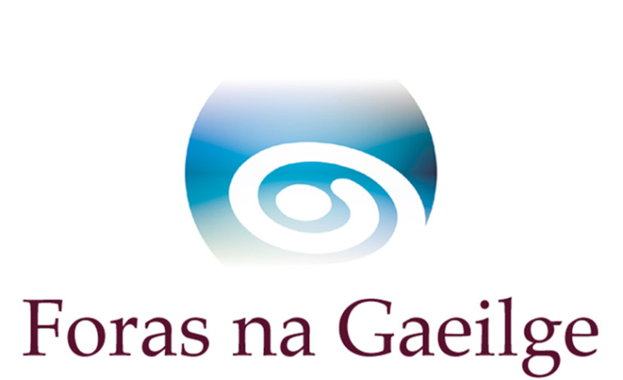

Colmcille Small Grants Scheme
for promoting initiatives or a partnership with Scotland

Maximum available €1,800/£1,566

Background

Colmcille is a partnership between Foras na Gaeilge in Ireland and Bòrd na Gàidhlig in Scotland. Colmcille aims to foster interaction and cooperation between speakers of Irish Gaelic and speakers of Scottish Gaelic, and to strengthen the two language communities.

Colmcille 1500

From the 7 December 2020 to the 7 December 2021 there will be a commemoration of 1500 years from the birth of St Colmcille (Columba) who founded the monastery of Iona. Colmcille is a symbol of cooperation between countries in these islands. In addition to the normal criteria, applications are welcome which raise awareness of the heritage of Colmcille and which bring people together, particularly between Ireland and Scotland.

Colmcille has three funding schemes:

- The small grants scheme for carrying out research and for planning joint initiatives
- The grants scheme for funding projects (the main Colmcille grants scheme)
- The bursaries scheme to help people learn Scottish Gaelic

If you want to develop an initiative with a partner in Scotland, or which will be connected to Scottish Gaelic, this small grants scheme (scheme 1 above) is to help develop joint initiatives and partnership. When the partnership and an initiative plan have been agreed under this small grants scheme, an application can be made to the Colmcille Grants Scheme (scheme 2 above, the main Colmcille grants scheme), which gives a higher level of support, if that is needed.

If you are interested in making an application speak with Colmcille officers in Foras na Gaeilge before you fill in the scheme application form.

Guidance for applicants to the Colmcille Small Grants Scheme

- Can I apply to the scheme?

The scheme is open to:

- organisations in Ireland or in Scotland wishing to develop an initiative with a partner in the other country.
- organisations seeking a partner or wishing to create a partnership.
- an individual who is in a position to implement a partnership project between Ireland and Scotland with a partner in the other country:
  - which will have a longterm outcome.
  - which will be of benefit to the general Irish language/Scottish Gaelic community.

- Do I have to receive a small grant before applying for the main Colmcille grants scheme?

No. This is an opportunity to establish a strong partnership before applying to the main Colmcille grants scheme, if that is considered worthwhile.

- What kind of costs can be included?

  - Travel, accommodation and subsistence necessary to put together a partnership plan demonstrating value for money and agreed in advance with Foras na Gaeilge.
  - Workshops or training to develop the initiative.
  - Any other activity which would be necessary in the opinion of Foras na Gaeilge and agreed in advance with Foras na Gaeilge.

- What work is to be done?

  - Essential research.
  - Agree an initiative plan with a partner in Scotland, or in Ireland if the applicant is a partner in Scotland.
  - Agree a plan for language use so that Irish and Scottish Gaelic can be used.

- And how will Foras na Gaeilge assess applications?

Foras na Gaeilge will assess applications according to the following questions:
  - Have you a partner in Scotland, or made contact with a possible partner? If yes please give details (name, description, address, email and telephone number).
  - What outcome do you wish to achieve with this small grant?
  - What are the goals you have for the work under the small grants scheme?
  - What research have you done to date and what are the outcomes of the research?
  - What work is to be done and what is the schedule?

- When should the money be spent?

The money should be spent and a report submitted before the end of the year if the application is made between January and June. If the application is made between July and December the money should be spent and the report submitted before six months from the date of the letter of offer.

- When will a decision be provided?

We hope that a decision will be available within six weeks after we have received an application. In the case of organisations which already have substantial funding from Foras na Gaeilge in 2019/2020 there may be a longer process.

