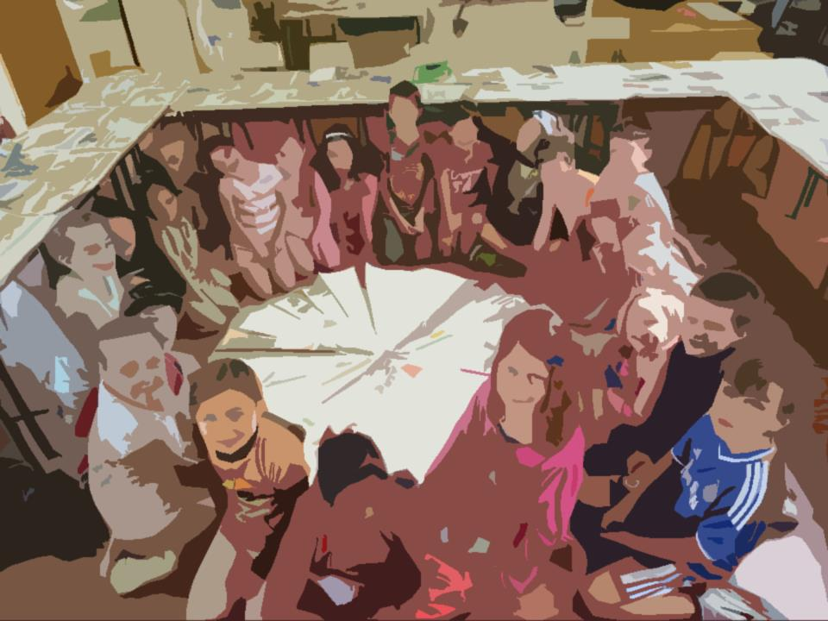
Foirm Iarratais
Application Form

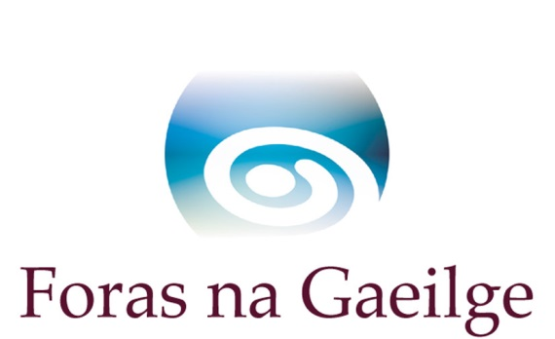

Scéim na nImeachtaí Óige

Imeachtaí le linn na scoilbhliana
Meán Fómhair 2025 - Meitheamh 2026
(Uasmhéid Maoinithe ar fáil €5,000/£3,500)

Caithfidh tú an fhoirm seo a chomhlánú i gCLÓSCRÍBHINN

Spriocdháta: 5pm, Dé Céadaoin, 30 Aibreán 2025

Youth Events Scheme

Events during the school year
September 2025 - June 2026
(Maximum Funding Available €5,000 / £3,500)

You must complete this form in TYPESCRIPT

Deadline: 5pm Wednesday 30th April 2025

Beidh oifigigh Fhoras na Gaeilge sásta aon cheist atá agat maidir leis an bhfoirm iarratais a fhreagairt roimh an spriocdháta.
Tabhair faoi deara go bhfuil muid ag obair ó chian, is gá teagmháil a dhéanamh linn ar ríomhphost oideachas@forasnagaeilge.ie

Foras na Gaeilge officers will be happy to answer any questions you have regarding the application form prior to the deadline.
Please note we are working remotely, you must contact us via email oideachas@forasnagaeilge.ie

Srianta Covid-19

Tá Foras na Gaeilge ag glacadh le hiarratais d’imeachtaí fisiciúla óige amháin ag an bpointe seo.  Féadfaidh tionchar a bheith ag an bpaindéim ar reáchtáil imeachtaí óige in 2025/26 mar gheall ar shrianta COVID-19.  Féadfaidh srianta a bheith i bhfeidhm nuair a bheidh imeachtaí óige ar siúl agus féadtar gur gá imeachtaí óige a chur ar líne nó a chur ar ceal. Tá foireann Fhoras na Gaeilge ar fáil le tacaíocht agus le treoir a chur ar fáil má tharlaíonn sé sin. Is faoin eagraíocht féin é, áfach, cinneadh a dhéanamh cad is oiriúnaí dóibh féin.  Molaimid:  - Imeachtaí atá oiriúnach don taobh amuigh agus ar líne  - Scaradh sóisialta agus mascanna a bheith éigeantach más cuí, le comharthaí ar taispeáint chun cuidiú leis an bhfoireann agus rannpháirtithe cloí leis na rialacha  - A rá le tuismitheoirí agus rannpháirtithe go bhféadfar go mbeidh imeachtaí óige ar siúl taobh amuigh nó ar líne nó go gcuirfear na himeachtaí óige ar ceal.  - Sábháilteacht na rannpháirtithe agus na foirne a bheith ina thosaíocht i gcónaí, agus measúnú riosca a bheith déanta, ag cur san áireamh riachtanais COVID-19  .  Tá gach faisnéis cothrom le dáta maidir le bearta sláinte poiblí ar fáil ag www.gov.ie/ga nó  www.healthni.gov.uk/coronavirus | Foras na Gaeilge are accepting applications for physical youth activities only at this point.  The pandemic may impact on the running of youth activities in 2025/26 due to COVID-19 restrictions.  Restrictions may be in place while youth activities are taking place and youth activities may have to be moved online or cancelled. Foras na Gaeilge staff are available to provide support and guidance if this happens. It will be the responsibility of the organisation itself, however, to decide what is most appropriate for themselves.  We recommend:  - Activities that are suitable for outdoors and online  - Social distancing and masks to be compulsory if appropriate, with signs displayed to help staff and participants comply with the rules  - Telling parents and participants that the youth activities may take place outside or online or that the youth activities may be cancelled  - That the safety of participants and staff be a priority at all times, and that a risk assessment be carried out, including COVID-19 requirements.  All up to date information on current public health measures is available at www.gov.ie/ga or www.healthni.gov.uk/coronavirus

Seicliosta Checklist

Dícháileofar d’iarratas mura bhfuil gach rud ón seicliosta thíos curtha leis, ach amháin má thagtar ar réiteach eile chun shástacht Fhoras na Gaeilge.

Má shíleann tú nach mbaineann aon rud ar an seicliosta leat, molaimid duit teagmháil a dhéanamh le hoifigigh Fhoras na Gaeilge sula gcuirfidh tú an t-iarratas isteach.

Tabhair faoi deara go gcaithfidh tú gach rud a chur ar fáil leis an iarratas seo, fiú má tá siad curtha chuig Foras na Gaeilge roimhe.

Your application will be disqualified if everything from the checklist below is not sent with it, unless an agreement is reached to the satisfaction of Foras na Gaeilge.

If you think that any item from the checklist does not pertain to you, we advise you to contact Foras na Gaeilge officers before you submit the application.

Please note that you must supply every item, even if previously submitted to Foras na Gaeilge.

- cóip leictreonach den fhoirm iarratais, comhlánaithe agus sínithe mar is cuí  - miondealú síos ar chostais – féach ceist ar an bhfoirm iarratais maidir le caiteachais an imeachta/na n-imeachtaí – is féidir leanúint ar leathanach breise más gá  - clár cuimsitheach don imeacht/do na himeachtaí  - seicliosta um chumhdach cuí comhlánaithe. Tá na seicliostaí agus treoir chun iad a líonadh ar fáil ar an suíomh  - bunreacht na heagraíochta nó meabhrán agus ailt na heagraíochta  - ráiteas caiteachais is deireanaí sínithe agus dátaithe ag cisteoir agus rúnaí/cathaoirleach an choiste nó cuntais iniúchta  - deimhniú imréitigh cánach (ó eagraíochtaí a fhaigheann €10,000 nó níos mó ó Fhoras na Gaeilge sa bhliain airgeadais reatha)  - ráiteas bainc is deireanaí in ainm na heagraíochta  - meastacháin neamhspleácha ar pháipéar sainchlóite do gach iarratas ar earra/ábhar/sheirbhís mar seo a leanas:  - suas go £1,000/€1,500 – 2 thairiscint bhéil,  - £1,000/€1,500 go £10,000/€15,000 – 3 thairiscint roghnaithe. | - an electronic copy of the application form, completed and signed as appropriate.  - detailed breakdown of costs – see question on application form regarding event(s) expenditure – you can continue on an additional page if neccessary  - a comprehensive programme for the event(s)  - completed relevant safeguarding checklist. Checklists and guidance to complete them are available on the website  - the organisation’s constitution or memorandum and articles  - most recent statement of expenditure signed and dated by treasurer and secretary/chairperson of committee or audited accounts  - tax clearance certificate (from organisations receiving €10,000 or more from Foras na Gaeilge in the current financial year)  - most recent bank statement in the name of the organisation  - independent quotes on headed paper for every application for goods/services as follows:  - up to £1,000/€1,500 – 2 verbal quotations,  - £1,000/€1,500 to £10,000/€15,000 – 3 selected quotations.

Má tá aon cheist agat faoi aon ghné den seicliosta seo, déan teagmháil linn le do thoil.
If you have any queries on any aspect of this checklist, please contact us.

Molaimid duit na Treoirlínte a léamh go cúramach sula gcomhlánóidh tú an fhoirm iarratais seo. Tá roinnt athruithe déanta sa scéim seo i mbliana. Níl cead ach iarratas amháin a dhéanamh ar son eagraíocht ar bith.

We recommend you read the Guidelines carefully before completing this application form. Several changes have been made to this scheme this year. Only one application may be submitted per organisation.

Má chuireann tú níos mó ná aon iarratas amháin isteach is gá duit na hiarratais a chur
in ord tosaíochta
If you make more than one application you must put the applications in order of
preference.

Ord tosaíochta an iarratais seo (Más seo an t-aon iarratas agat cuir “1”):
Order of preference of this application (If this is your only application put “1”)

Deimhním go gcomhlíonann an eagraíocht critéir cháilitheacha uile na scéime (cuir tic)

I confirm that the organisation fulfils all qualifying criteria for the scheme (enter tick)

1. Ainm na heagraíochta
Name of organisation
2. Ainm an phríomhtheagmhálaí
Name of primary contact

Ainm an dara teagmhálaí
Name of second contact
3. Seoladh agus cód poist / Éirchód an phríomhtheagmhálaí
Address and post code / Eircode of the primary contact

4. Uimhir fóin an phríomhtheagmhálaí
Telephone number of primary contact

Uimhir fóin an dara teagmhálaí
Telephone number of second contact
5. Ríomhphost an phríomhtheagmhálaí
E-mail of primary contact

Ríomhphost an dara teagmhálaí
E-mail of second contact

6. Seoladh agus uimhir theagmhála
an ionaid do na himeachtaí
Address and Contact number for the centre in which the activities will take place.
7. a) Toghcheantar Dála/Tionóil
Dáil/Assembly electoral district
b) Toghlimistéar áitiúil
Local electoral area

(a mbeidh na himeachtaí ar siúl)
(where the events will take place)
8. Uimhir chláraithe chánach
Tax registration number
Uimhir charthanachta
Charity number
9. Ainm na n-imeachtaí
Name of events

10. Dátaí na n-imeachtaí
Lá agus am
Dates of events
Day and time

m.sh. Gach Luan 7-9in ó 01.09.25 go 30.06.26

e.g. Every Monday 7-9 from 01.09.25 to 30.06.26
11. Costas iomlán an tionscadail
Total cost of project
12. Méid an deontais atá á lorg ó Fhoras na Gaeilge:
Amount of grant sought from Foras na Gaeilge:

13. Stiúrthóirí/coisteoirí | Directors/committee members

Sonraí teagmhála an chathaoirligh má tá sé éagsúil ó na teagmhálaithe luaite faoi cheist 2
Chairperson’s contact details if different from the contacts listed under question 2

Ainm Name | Uimhir fóin  Telephone number | Ríomhphost  E-mail

Sonraí bhaill eile coiste
Other committee members’ details

Ainm | Name | Ról | Role | Taithí nó scileanna cuí |  Experience or relevant skills

14. Foireann do na himeachtaí | Staff for the events

Ainm | Name | Ról | Role | Taithí | Experience

15. Cumhdach Leanaí Child Safeguarding

**Tabhair faoi deara go gcaithfidh seicliosta cumhdach leanaí don dhlínse chuí a bheith curtha isteach leis an iarratas, tá na seicliostaí agus treoir chun iad a líonadh ar fáil ar an suíomh. Ní gá an polasaí a chur chugainn**
**Please note that a safeguarding checklist for the relevant jurisdiction must be submitted with this application, checklists and a guide on how to complete them are available on our website. We don’t require a copy of your policy**

Deimhním le X sa bhosca thar ceann na stiúrthóirí go mbeidh gach ball foirne a bheidh ag plé leis na daoine óga le linn an imeachta/na n-imeachtai cáilithe mar is cuí agus go mbeidh grinnfhiosrúchán déanta air. (Cuir tic sa bhosca)

I confirm with an X in this box on behalf of the directors that a all staff members dealaing with youths during the event will be fully qualified and that each youth leader will be vetted (tick the box)

Eagraíochtaí suite sa dlínse ó dheas
Organisations located in the southern jurisdiction

Deimhním le X sa bhosca seo go bhfuil polasaí um chumhdach ag an eagraíocht atá ag teacht le Treoir Náisiúnta um Thús Áite do Leanaí 2017

I confirm with an X in this box that the organisation has a policy for child safeguarding in accordance with the Children First National Guidance 2017.

Eagraíochtaí lonnaithe sa dlínse ó thuaidh
Organisations located in the northern jurisdiction

Deimhním le X sa bhosca seo go bhfuil polasaí scríofa ar chumhdach ag an eagraíocht, faofa ag bord bainistíochta

I confirm with an X in this box that the organisation has a written policy on safeguarding, approved by a management board.

Dáta is deanaí a rinneadh athbhreithniú ar an pholasaí um chumhdach leanaí:____________
The most recent date that the child safeguarding policy was reviewed: __________

16. An bhfuil d’eagraíocht cláraithe le Access NI nó le scátheagras (ó thuaidh amháin)? Tabhair sonraí le do thoil.

Is your organisation registered with Access NI or with an umbrella organisation (in Northern Ireland only)?
Please give details.

17. Cé mhéad bliain de thaithí atá ag d’eagraíocht idir fhoireann agus bhaill choiste ag eagrú imeachtaí do dhaoine óga? Ní gá go mbainfeadh an taithí go sonrach leis an scéim seo.  Cuir tic sa bhosca cuí.  How many years experience does your group have, including staff and committee members organising events for young people? This experience may not necessarily relate to this scheme.  Tick the appropriate box. | Is é seo ár gcéad bhliain  This is our first year  1-2 bhliain 1-2 years  3-4 bliana 3-4 years  5+ bliana / 5+ years

18. Ar smaoinigh sibh ar aon dóigh eile leis an scéim seo a chur i bhfeidhm? Cén fáth gur seo an rogha is fearr do do cheantar?
Did you consider any other ways to run this scheme? Why is this the best choice for your area?

19. Conas a chuirfidh na himeachtaí seo le deiseanna úsáide Gaeilge do dhaoine óga?
How will these events add to young people’s opportunities to use the Irish language?

20. An bhfuil imeachtaí den chineál seo ar siúl sa cheantar cheana? Cuir tic sa bhosca chuí.
Are there events of this type alreadytaking place in the area? Tick the appropriate box.

Tá

Níl

Má tá, inis dúinn faoina himeachtaí seo (ainm an ghrúpa, ceantar etc.) agus inis dúinn an dóigh a ndéanfaidh sibh comhoibriú leis na himeachtaí eile seo le cur le deiseanna úsáide Gaeilge do dhaoine óga

If so, please tell us about these events (name of group, area etc.) and tell us how you will co-operate with these other events to increase the opportunities for young people to use Irish

Má tá, cad é mar a chuirfidh na himeachtaí luaite ar an bhfoirm seo leis na himeachtaí atá ann cheana féin do na daoine óga sa cheantar?

If so, how will the events listed on this form add to the current events in your area for young people?

21. Áiseanna atá ar fáil san ionad do na himeachtaí
Facilities available at the centre for the events

22. Líon iomlán daoine óga lena bhfuil sibh ag súil le linn thréimhse na scéime
Total expected number of young people during the duration of the scheme

23. Táille an pháiste in aghaidh an tseisiúin
Fee per child per session

24. Cé air a bhfuil an clár imeachtaí dírithe?  Cuir tic sa bhosca cuí. Má tá meascán ann, cuir tic sa dá bhosca.  Who is the events programme focused on?  Tick the appropriate box. If there is a mixture, tick both boxes. | Tá an scéim seo ag freastal ar dhaoine óga le Gaeilge agus daltaí gaelscoile  This scheme caters for young people with Irish and Gaelscoil pupils  Tá an scéim seo ag freastal ar dhaoine óga atá ag foghlaim nó atá ar bheagán Gaeilge  This scheme caters for young people who are learning or who have little Irish
24a. Polasaí Árachais
Insurance Policy

Deimhním le X sa bhosca thíos go bhfuil/go mbeidh gach imeacht atá sa chlár imeachtaí clúdaithe faoi pholasaí cuí árachais atá bailí.

I confirm with an X in the box below that all events in the programme of events are/will be covered by an appropriate, valid insurance policy.

Deimhním I confirm

25. Clár Imeachtaí | Programme of Events

Lá  (laethanta)  Day  (days) | Dáta(í)  Date(s) | Am  Time | Imeacht  Event | Sprioc foghlamtha  Learning intention

Is féidir leanúint ar leathanach eile más gá.
Má bhíonn aon athrú ar an gclár ama seo, ó thaobh laethanta, dátaí, ná imeachtaí de, nó líon na ndaoine óga, caithfidh do ghrúpa sin a aontú i scríbhinn le Foras na Gaeilge.

Continue on additional page if necessary.
If there are any changes in this programme, as to days, dates or events, or number of young people, your group must agree this in writing with Foras na Gaeilge.

26. Costas iomlán réamh-mheasta na n-imeachtaí | Projected total cost of Events

Cur Síos ar an gcaiteachas  Description of expenditure | Briseadh Síos  Ní mór briseadh síos ar na príomhfhigiúirí a thabhairt – i.e. ráta in aghaidh na huaire don teagascóir/cheannaire, líon uaireanta, líon laethanta etc.  Break down  A breakdown of the main figures must be given – i.e. rate per hour for tutor/leader, number of hours, númber. of days etc. | Costas iomlán tuartha  Total predicted cost | Deontas iarrtha ó Fhoras na Gaeilge do 2025  Grant requested from Foras na Gaeilge for 2025 | Deontas iarrtha ó Fhoras na Gaeilge do 2026  Grant requested from Foras na Gaeilge for 2026
Teagascóirí
Tutors

*Cuir san áireamh an costas in aghaidh an tseisiúin agus líon na seisiún
*Include cost per session and number of sessions
Ceannairí
Leaders

*Cuir san áireamh an costas in aghaidh an tseisiúin agus líon na seisiún
*Include cost per session and number of sessions

Cíos
Rent
Árachas
Insurance
Turas
Trip

*Tabhair faoi deara nach dtugann Foras na Gaeilge maoiniú do thurais imchónaithe
*Please note Foras na Gaeilge do not fund residential trips
Trealamh
Equipment
Áiseanna
Resources

*Ní mór d’áiseanna ar bith atá maoinithe ag Foras na Gaeilge fanacht i seilbh an choiste
*Any resources funded by Foras na Gaeilge must remain in the possession of the committee.

Aon chaiteachas eile (tabhair sonraí le do thoil)
Any other expenditure (please provide details)
Iomlán Total

27. An bhfuil an eagraíocht ag fáil aon mhaoiniú eile ó Fhoras na Gaeilge ón 1 Eanáir 2025 nó an bhfuil iarratas déanta agaibh?
Is the organisation receiving any other funding from Foras na Gaeilge since 1 January 2025 or have you made an application?

Tá

Níl

Má tá If yes

Ainm an tionscadail
Name of project

Stádas, i.e. curtha isteach/faighte
Status i.e. applied for/granted

Uimhir thagartha (más cuí)
Ref. number (if appropriate)

Méid an mhaoinithe atá iarrtha/ bronnta
Amount of funding requested/granted

28. Foinsí eile maoinithe don tionscadal seo (más ann dóibh):
Other sources of funding for this project (if they exist):

Ainm agus seoladh an mhaoinitheora
Name and address of funder

Uimhir theagmhála an mhaoinitheora
Contact number of funder

Méid an mhaoinithe iarrtha/ceadaithe/faighte
Amount of funding applied for/approved/received

29. An bhfuil coimhlint leasa ag aon bhall foirne de chuid Fhoras na Gaeilge nó aon chomhalta boird de chuid Fhoras na Gaeilge i leith an iarratais seo? Má tá tabhair sonraí le do thoil.
Does any member of staff or board member of Foras na Gaeilge have a conflict of interests regarding this application? If yes, please give details.

Tá

Níl

Ainm an duine:
Name of person:

Eolas:
Information:

30. Cá háit ar chuala tú faoin scéim seo?
Where did you hear about this scheme?

Dearbhú

Dearbhaímid go bhfuil an t-eolas atá san iarratas seo cruinn ceart agus go bhfuil an t-iarratas ag teacht le critéir na scéime. Tuigimid go bhféadfaidh Foras na Gaeilge an t-iarratas a chur ar ceal má tá aon eolas míchruinn tugtha.

about this schemeWe confirm that the information given in this form is correct and that the application meets the criteria for the scheme. We understand that Foras na Gaeilge may cancel this application if any incorrect information is given.

Cuir tic sa bhosca
Tick the box

Teagmhálaí Contact
Ainm
Name
Stádas san eagraíocht
Status in the organisation
Dáta
Date

Dearbhaím go ndearnadh an t-iarratas ar mhaoiniú seo ar thar ceann an bhoird stiúrtha nó coiste na heagraíochta. Dearbhaím go bhfuil na stiúrthóirí/ an coiste ar an eolas go ndearnadh an t-iarratas seo.
I confirm that this application was made on behalf of the bord or committee of the organisation. I confirm that directors / committee members are aware that this application was made.

Thar ceann an bhoird stiúrtha nó coiste na heagraíochta
On behalf of the board or committee
Ainm
Name
Stádas san eagraíocht
Status in the organisation
Dáta
Date
Ní ghlacfaimid le hiarratas ar bith gan an dearbhú seo a bheith comhlánaithe mar is ceart. Glacfaimid le síniú leictreonach.
We will not accept any application which does not have this declaration completed correctly. We will accept electronic signatures.

Is gá an fhoirm chomhlánaithe agus na cáipéisí tacaíochta a chur go leictreonach chuig oideachas@forasnagaeilge.ie ní ghlacfar le hiarratais tríd an phost.

The completed form and supporting documents must be sent electronically to oideachas@forasnagaeilge.ie applications through the post will not be accepted.

