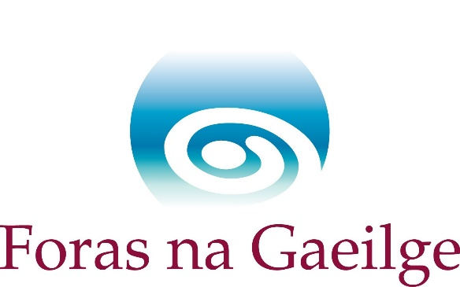

Professional Drama Companies’ Scheme 2026
Guidelines for Applicants

Guidelines
These guidelines provide information on the Professional Drama Companies Scheme 2026.
They will help you:
Decide whether your organisation is eligible to apply for funding under this scheme
Prepare an application which contains all the information needed.
Please read them carefully before you begin to complete the application form.
About this scheme
Foras na Gaeilge is providing funding to legally established professional drama groups, including newly established professional groups, who wish to produce Irish language or bilingual plays around the country and abroad. This scheme focuses on Irish language drama companies which aim to foster, develop and provide Irish language drama to the arts sector, the Irish language community, the general public and the education sector. This scheme also focuses on community development, increased attendance and audience development.
- Grants are provided with public money, and Foras na Gaeilge has statutory duties to ensure the value for money of all funded projects.
- Foras na Gaeilge recommends applicants seek joint funding for projects, when appropriate, and to cooperate with other organisations in order to achieve the best value from the Foras na Gaeilge grant.
- We particularly welcome applications from organisations located in areas recognised in government strategies or legislation.
Can we apply?
To be eligible to apply for this scheme your organisation must be able to fulfil the following qualifying criteria:

- The company can demonstrate that the main aims of the elements of the project for which funding is sought are the promotion of the Irish language and the provision of opportunities for the use of Irish.
- The company can demonstrate that there is a need for the project and that value for money is available to Foras na Gaeilge
- The company has a strategy to grow the number of people who will be participating, including members of the company, production personnel and attendees.
Foras na Gaeilge may add to these qualifying criteria.
If you have any question on any aspect of the qualifying criteria, you can contact Foras na Gaeilge before the deadline.
How will Foras na Gaeilge assess the applications?
Foras na Gaeilge uses assessment criteria to assess applications. The assessment criteria of the scheme are set out below, as laid out in the application form. We will assess and score applications in accordance with these criteria.
- The subject of the plays, number of productions and venues of the productions, imagination and innovation of the company’s programme of work

- High artistic standards achieved in scripts, acting and productions

- Increase participation and creativity in Irish through the medium of the arts

- Use of Irish on the company’s publicity

- Information on other funding and support, e.g. sponsorship, funding in kind and estimated income

- Value for money regarding the number of people who will be participating, including members of the company, production personnel and attendees.

- Strategy to increase those participating in activities, between company members, production team and audiences.

- Estimate of number of people who will participate, including company members, performers and audiences.

- Management and administration capacity which will include the company’s experience and expertise.

Types of funding available:
Professional groups | New professional groups
Maximum €50,000/£42,000  Costs of the company’s programme of work will not be 100% funded | €24,000/£20,160  Permission to apply for 100% of annual programme costs

Who is ineligible to be an applicant?
- Legislative bodies and lead organisations
- Any company canvassing in respect of an application any board member or any employee of Foras na Gaeilge
- Amateur Drama Groups
Activities eligible for funding through the scheme
- Productions through the medium of Irish or which are bilingual but with Irish in first position.
- Development of new scripts
- Development of new plays
Activities not eligible for funding through the scheme
- Productions through the medium of English
- Productions within the programme for which funding has already been secured or sought from Foras na Gaeilge
Particular requirements:
- The company has a constitution
- Public liability insurance
- Appropriate safeguarding checklist must be completed
- A bank account in the name of the company
- Valid ROS tax number (If appropriate)
- Current tax clearance certificate (If appropriate)

How will we apply?
Before you start to complete the application form read the guidelines fully again and ensure that your organisation fulfils the scheme qualifying criteria above.
Only applications submitted electronically will be accepted. Hard copies of applications will not be accepted. As you complete the application you must answer all questions.
The deadline for applications is 12.00 midday, Friday 24/04/2026.
It is up to the organisation itself to ensure that the application is completed and submitted on time. We will not accept any applications after the above deadline.
If you have any question about any aspect of the application contact Foras na Gaeilge before the deadline.
What will happen to our application?
Foras na Gaeilge will assess all valid applications under the criteria stated above.
Any application in which inaccurate information is given will be disqualified.
It is the executive of Foras na Gaeilge that is responsible for all decisions regarding all projects to be funded, and who will implement all funding decisions.
If our application is successful?
If your application is successful, we will make you an offer in which there will be all relevant information on payment and monitoring of the scheme.
This offer will be a legal contract and the conditions of this contract must be adhered to. Any portion or all of the grant may be cancelled or recalled if any of the terms or conditions of the contract are violated.
- There must be a bank account in the name of the organisation, under the control of a committee or board. All payments from the Foras na Gaeilge grant should be made from this account so that there is a written account available of all payments (e.g. cheque, direct debit, bank cards associated with the account, BACS etc.).
- A personal bank, visa or other card cannot be used and repayments will not be approved from the account to a personal card in any case.
- Foras na Gaeilge will not provide funding for payments made with cash.
- Foras na Gaeilge will not fund any spending not approved in advance. No grants will be paid retrospectively.
How can I give feedback, make a complaint or appeal?
Foras na Gaeilge welcomes any recommendations or feedback you may have about this scheme.
If you have cause for complaint about this scheme this can be made known to Foras na Gaeilge as well.
Foras na Gaeilge has an appeals process in place. If you are not happy with the decision made in respect of your application you can seek in writing a review within fourteen days from the date of the offer about the decision. All appeals must be based on these grounds only:
- That Foras na Gaeilge misread the information given during the assessment.
- That Foras na Gaeilge departed, in a substantial way, from the assessment process itself.

